Basic Examples of Machine Learning for Students
Machine Learning is used in our daily lives, often without us realizing it. Here are some simple, real-world examples that you can explain to college students.

1. Email Spam Detection
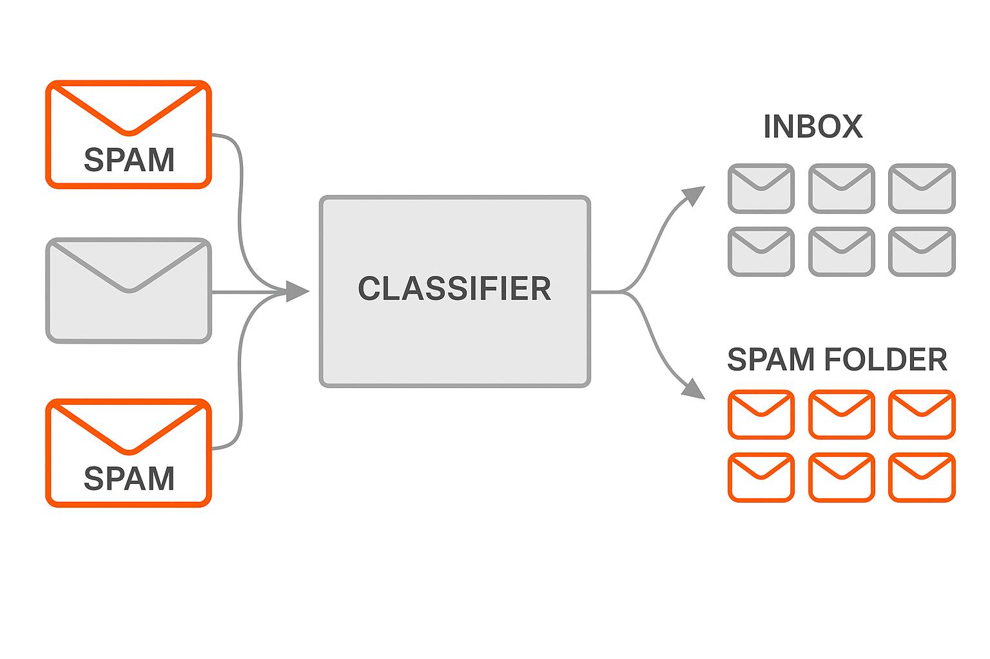
Concept: Supervised Learning – Classification
Example:
- Gmail receives an email.
- The ML model checks the sender, subject, links, and words.
- It identifies patterns from previously labeled emails.
- It predicts whether the email is Spam or Not Spam.
Email Content | Prediction
Congratulations! You won a lottery | Spam
Meeting scheduled at 10 AM | Not Spam
Claim your free cash prize | Spam

2. House Price Prediction
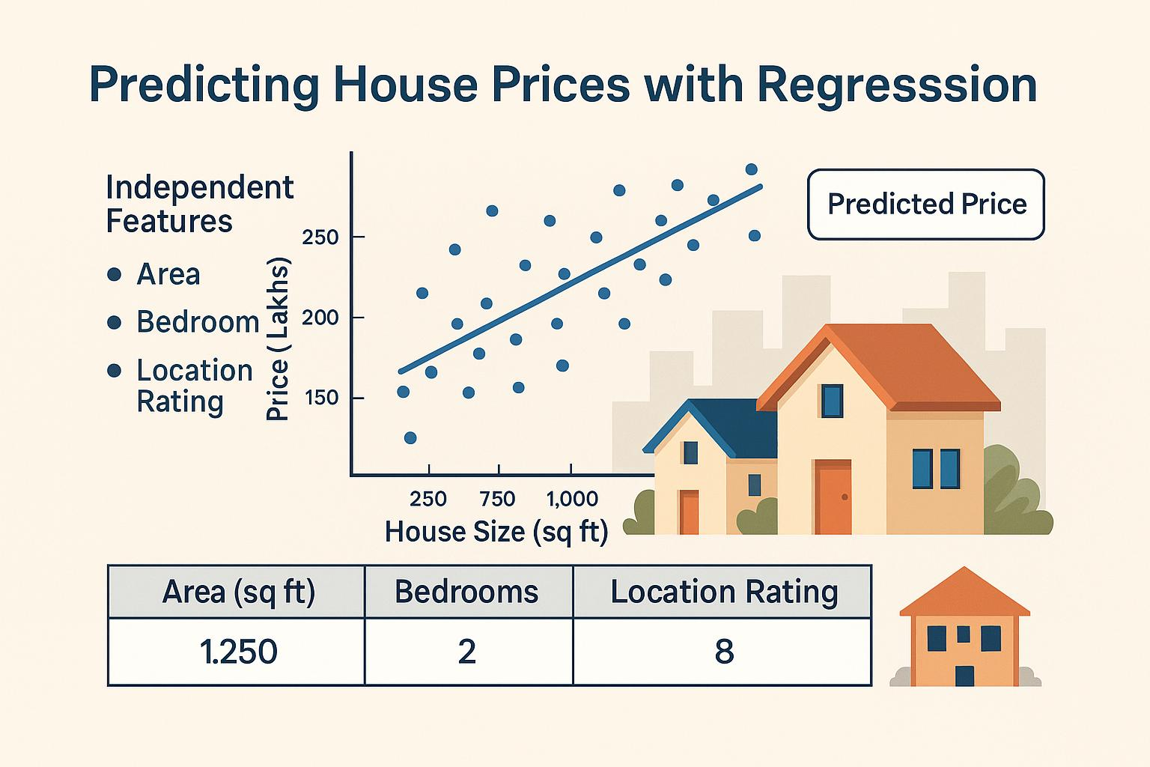
Concept: Supervised Learning – Regression
Example: A real estate company wants to predict house prices based on:
- Location
- House area
- Number of bedrooms
- Number of bathrooms
Area (sq.ft.) | Bedrooms | Price (₹)
1,000 | 2 | 35 Lakhs
1,500 | 3 | 50 Lakhs
2,000 | 3 | 65 Lakhs
2,500 | 4 | 80 Lakhs
If a new house has an area of 1,800 sq.ft., the model predicts its approximate price based on learned patterns.
Example
from sklearn.linear_model import LinearRegression
# House area
X = [[1000], [1500], [2000], [2500]]

# House prices in lakhs
y = [35, 50, 65, 80]
model = LinearRegression()
model.fit(X, y)
price = model.predict([[1800]])
print("Predicted Price:", price[0], "Lakhs")
3. Student Pass or Fail Prediction

Concept: Supervised Learning – Classification
Example: A college wants to predict student results based on study hours.
Student | Study Hours | Result
A | 1 | Fail
B | 2 | Fail
C | 5 | Pass
D | 6 | Pass
E | 8 | Pass
If a new student studies for 7 hours, the model may predict Pass.

Example: Student Pass/Fail Prediction
from sklearn.tree import DecisionTreeClassifier
# Training data
X = [[1], [2], [3], [5], [6], [8]]
y = ["Fail", "Fail", "Fail", "Pass", "Pass", "Pass"]
# Create model
model = DecisionTreeClassifier()
# Train model
model.fit(X, y)
# Predict result
result = model.predict([[7]])
print("Student Result:", result[0])
4. Movie Recommendation System

Concept: Recommendation Systems
Example: Netflix or YouTube recommends content based on:
- Previously watched movies
- Search history
- User interests
- Ratings and viewing patterns
If you frequently watch action movies, the system may recommend more action movies.
5. Face Recognition

Concept: Machine Learning / Deep Learning
Example: Smartphone face unlock.
- The camera captures your face.
- The system analyzes facial features.
- It compares them with previously enrolled facial data.
- It determines whether the face matches.

